Test Summary Report

**1. Report Description** **2**

**2. Application Overview** **2**

**3. Testing Objective** **2**

**4. Testing Scope** **2**

a) In Scope 2

b) Out of Scope 2

c) Items not tested 2

**5. Metrics** **3**

a) No. of test cases passed/failed/incomplete 3

b) Status Distribution (Feature-wise) 4

c) Status Distribution (Module-wise) 4

f) No of defects identified and their Status & Severity 5

**6. Category of testing performed** **5**

**7. Types of testing performed** **5**

**8. Test Environment & Tools** **5**

## 

## 

## 

## 

## 

## 

## 1. Report Description

This document explains the various activities performed as part of the testing of the ‘Quickteller’ application.

## 2. Application Overview

Quickteller is an easy-to-use, multi-channel payments platform designed to make payments an easy and enjoyable experience. The platform connects users to over 8,000 billers, enabling individuals to pay for just about anything from the comfort of their mobile devices.

## 3. Testing Objective

A functional test was carried out on this application/sprint to verify the app's functionality.

## 4. Testing Scope

### a) In Scope

Functional Testing for the following modules is within the scope of testing

* Sign Up
* Log in
* Forgot Password

### b) Out of Scope

Performance Testing was not done for this application.

### c) Items not tested

* Chat bot
* Help
* T and Cs

## 5. Metrics

### a) No. of test cases passed/failed/incomplete

|  |  |  |
| --- | --- | --- |
| **CHROME** | **Total Cases** | **36** |
| **Passed** | 29 |
| **Failed** | 5 |
| **Incomplete** | 2 |

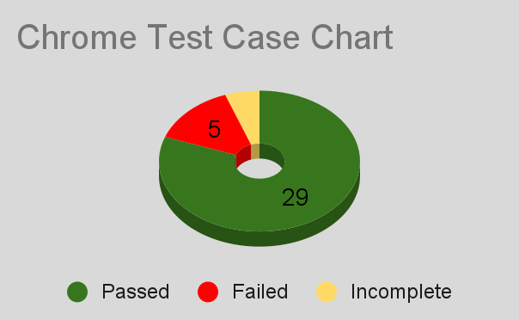

|  |  |  |
| --- | --- | --- |
| **FIREFOX** | **Total Cases** | **36** |
| **Passed** | 29 |
| **Failed** | 5 |
| **Incomplete** | 2 |

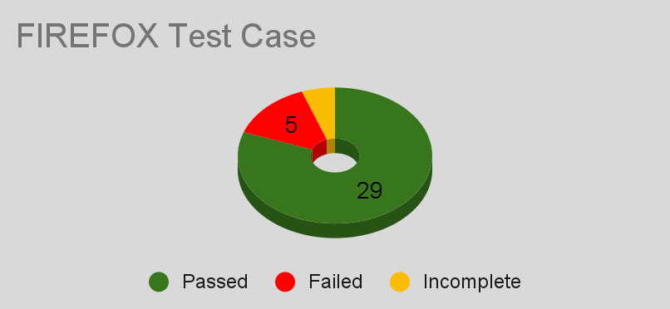

|  |  |  |
| --- | --- | --- |
| **EXPLORER** | **NOT EXECUTABLE** | |
| **Passed** | - |
| **Failed** | - |
| **Incomplete** | - |

### b) Status Distribution (Feature-wise)

This table shows features for Chrome (which can be used to depict Firefox as they have the same data).

|  |  |  |  |
| --- | --- | --- | --- |
|  |  | Android 11 |  |
|  |  |  |  |
| Severity | Low | Medium | High |
|  | 12 | 10 | 0 |
|  |  |  |  |
| Priority | Low | Medium | High |
|  | 7 | 8 | 7 |

### 

### c) Status Distribution (Module-wise)

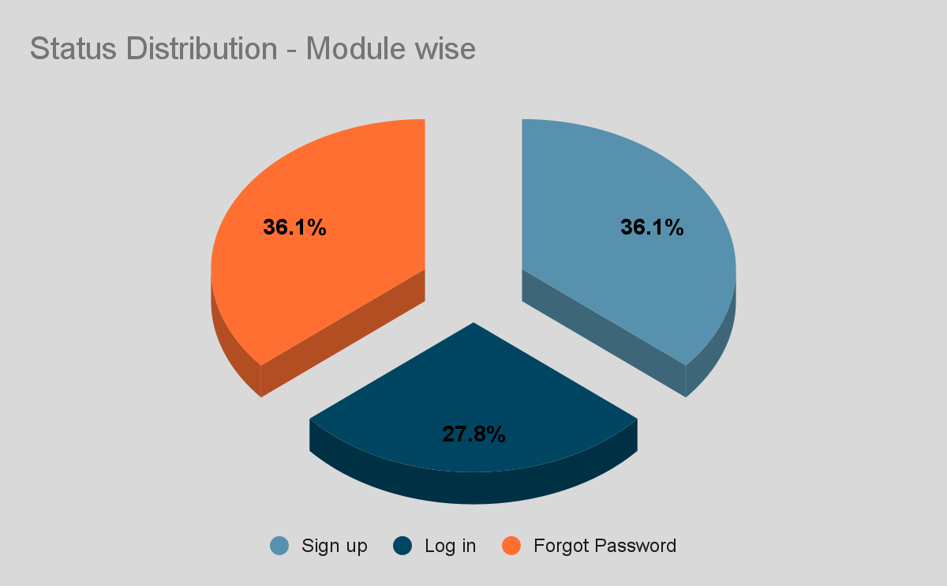

### f) No of defects identified and their Status & Severity

|  |  |  |  |  |  |
| --- | --- | --- | --- | --- | --- |
|  | Critical | Major | Medium | Low | Total |
| Closed | 0 | 0 | 0 | 0 | 0 |
| Open | 0 | 0 | 3 | 2 | 5 |
|  | | | | | 5 |

## 6. Category of testing performed

***Black Box Testing***

It is a software testing method in which the internal structure of the item is not known to the tester. Incorrect/missing function and behavior errors were tested.

## 

## 7. Types of testing performed

a) ***System Integration Test*** - it's conducted on a complete integrated component to verify it meets specifications. Critical Business scenarios were tested to make sure important functionalities in the application work as intended without any errors.

b) ***Regression*** - it confirms that a recent change in program/code or an update doesn’t affect the functionality of other features.

## 

## 8. Test Environment & Tools

|  |  |
| --- | --- |
| Application URL | https://quickteller.com/ |
| Apps Server | 192.168.0.103. |
| Database |  |
| HP QC/ALM | 192.168.0.103. |